**The flow of water in a friction free pipe**

**Assumptions:**

- No Friction

- Constant pipe radius

- Constant flow velocity

- Pipe insulated( heat)

- constant fluid pressure

- A contaminant( bad stuff) is possibly present, not uniformly, in the flow.

**Question:**

Where did it come from?

The pipe is long

along the pipe are sources of waste( contaminant) whose concentration must obey legal conditions.

**Building the model:**

x(m)- length along the pipe

x=0 - entrance point of flow

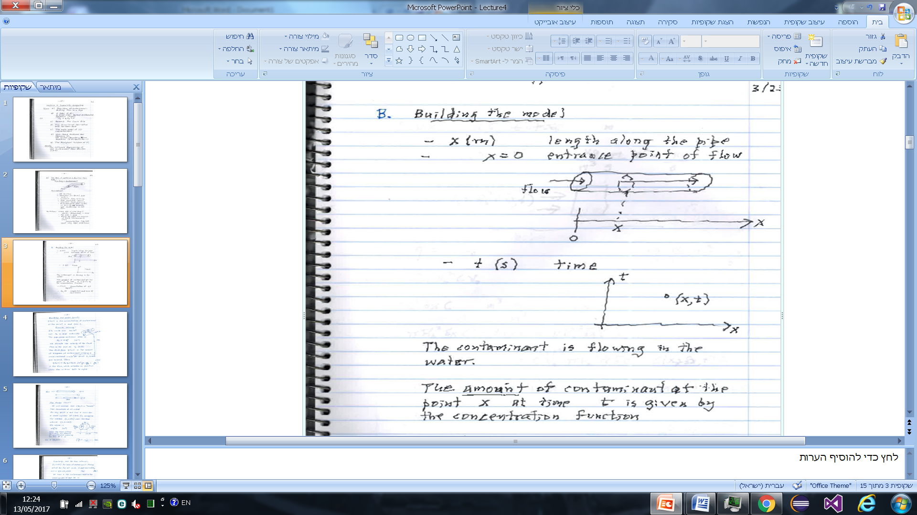

The contaminant is flowing in the water.

The amount of contaminant at the point x at time t is given by the concentration function.

C(x,t)- concentration at x,t (KG/M**3**)

t- length(m) and time(s) incrementsﬥ,xﬥ

C(x,t) is the concentration of contaminant at the point x and time t.

The units are KG/M**3**

Let R0 =pipe radius(m)

The pipe cross sectional area is: A0 =πR02 (m2)

We denote the velocity of the fluid flow in the pipe v0 (m/s)

The fluid flux q(x,t) is the number of kilograms of contaminant crossing a cross- sectional circle at point x, time per second.

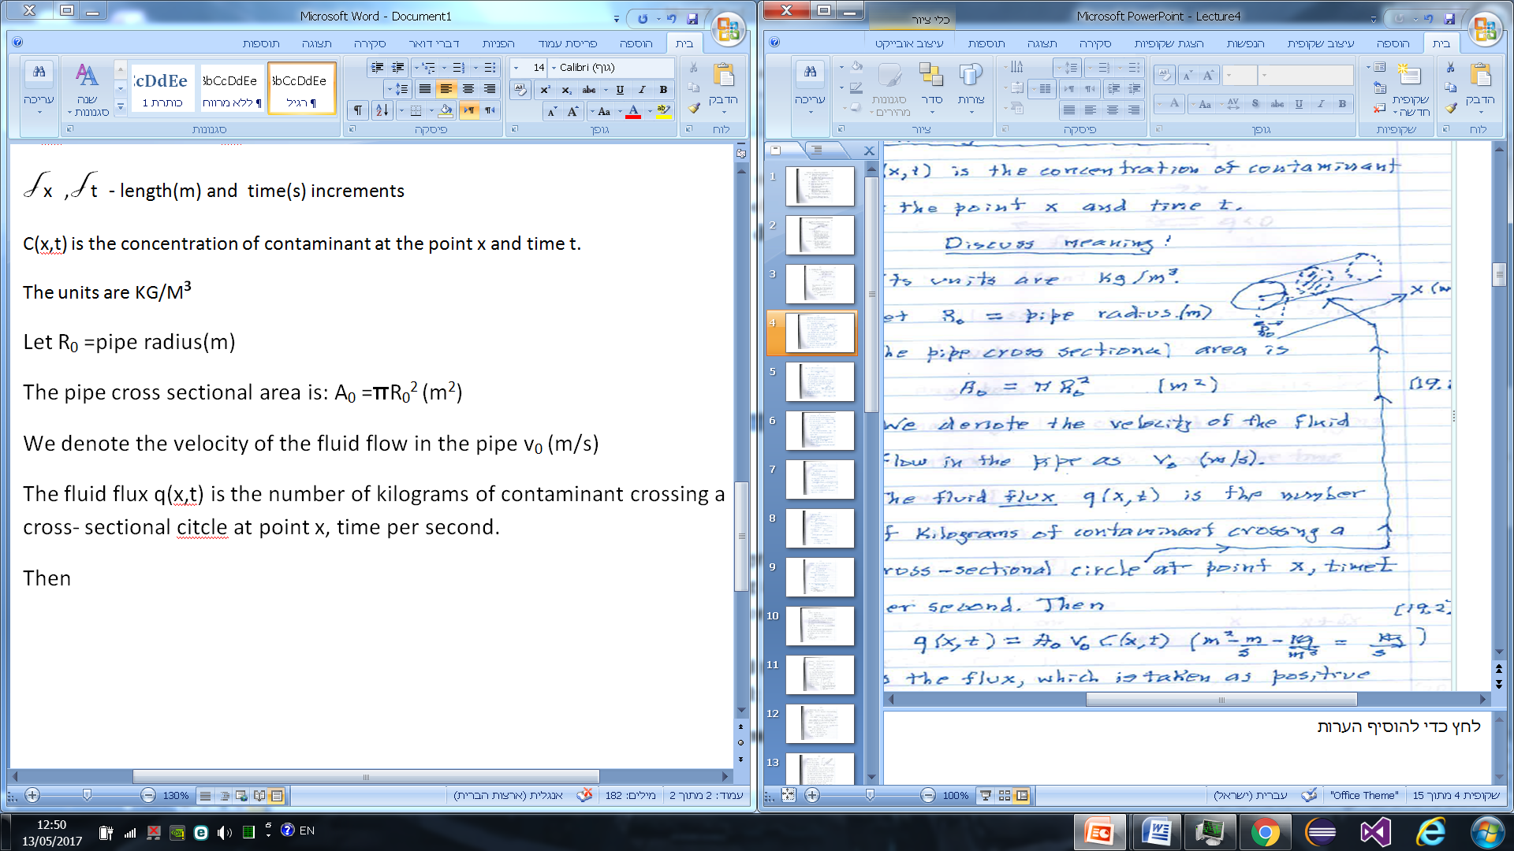

Then

Q(x,t)= R0*V0*c(x,t)

[kg/s]

is the flux, which is taken as positive when flow is from left to right

**The model:**

We will assume that C(x,t) is smooth( has derivatives of all orders)

For any point x and time t consider a small cylinder of width

x , occupying the interval [x,x+ deltaX] over the time interval [t,t+delta t]ﬥ

It's volume is :πR02deltaX [m3]

Over the time interval [t,t+delta t] the amount of contaminant crossing the face at x is IN= q(x,t) delta t (kg/s)

Also the mass of contaminant flowing out at [x,x+ deltaX] is

OUT= q(x+ delta x, t) delta t

At time t the contaminant mass in the small cylinder is:

ATT= πR02*c(x,t) delta x [kg]

While at time t+ delta t it is:

ATT+ :πR02*c(x,t+delta t) delta x[ kg]

The principle of concentration of mass implies that:

The mass of contaminant in our small cylinder ATT+ at time t+delta t is equal to the amount that was in the cylinder at time t, given by ATT plus the amount entering from the left face IN **minus** the amount leaving from the tight OU T.

Thus:

ATT+= ATT +IN- OUT

Or :πR02*c(x,t+delta t) delta x=

πR02 *c(x,t) delta x **+** q(x,t) delta t -q(x+ delta x, t) delta t

Dividing both sides of the equation by πR02 delta x delta t yields:

( c(x,t+delta t)- c(x,t) )/ (delta t) +

+v0( c(x+delta x, t)- c(x,t) )/ (delta x) = 0

***This is the contaminant transport equation( CTE)***

We say that the function c(x,t) is a solution of the CTE if it obey the equation

Example: C(x,t)= constant obey Ct +V0*Cx = 0

for any V0

Example: C(x,t)= 5sin(x-3t) solves the CTE: Ct+ 3Cx =0

**The CTE process Model- Characteristics:**

The function C(x,t) for each value of t, provides us with the distribution of the contaminant along the length of the pipe.

Suppose C(x,t) satisfies the following problem: **The Initial Value Problem(IVP)**

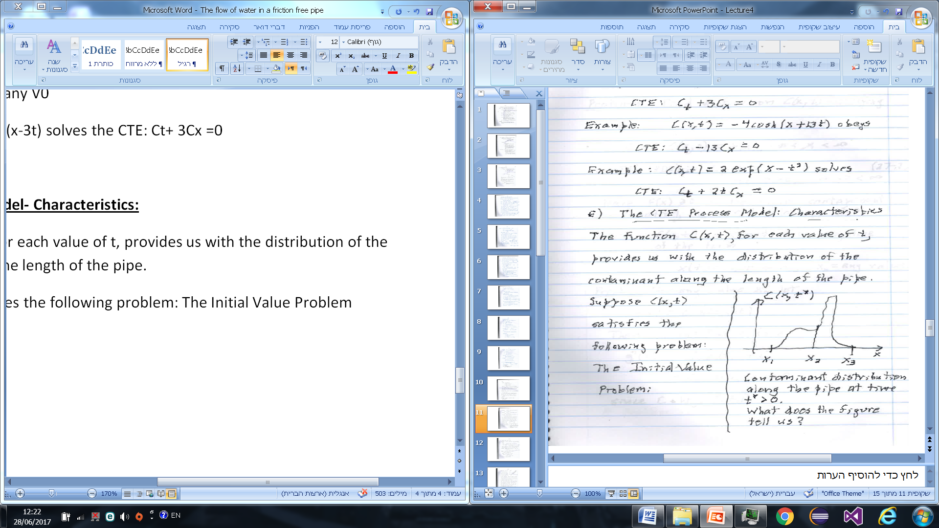

Contaminant distribution along the pipe at time t*>0

What does the figure tell us?

**IVP for the CTE:**

**Problem:** Find a function c(x,t) satisfying the IC:

c(x,0= f(x), -oo< x< oo

CTE(PDE): Ct+ V0*Cx= 0, for t>0, -oo<x<oo

Here f(x) >=0 is the initial contaminant distribution, V0= real veocity( >,<0)

**Claim:**

C(x,t) is the constant on any line of the form.

x(t)= V0*t+ X0, X0= any value

**Proof:**

for any value X0 let g(t)= C(x,t).

Then by the chain rule, g'(t)= Cx X'(t) + Ct= Ct+ V0*Cx= 0.

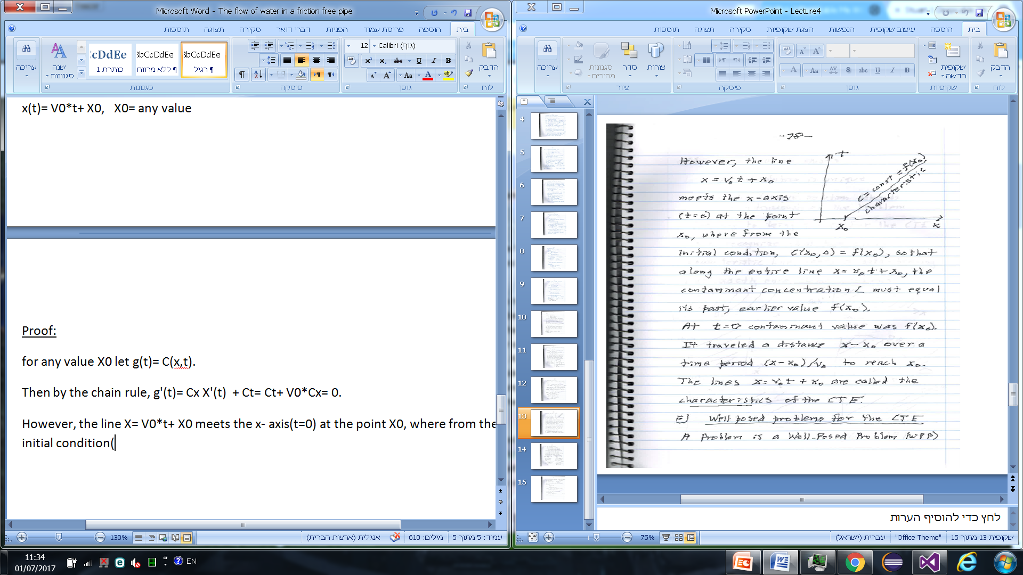

However, the line X= V0*t+ X0 meets the x- axis(t=0) at the point X0, where from the initial condition, C(X0,0)= f(X0), so that along the entire line x=V0*t+ X0, the contaminant concentration L must equal it's past, earlier value f(X0).

At t=0 contaminnat value was f(X0). It traveled a distance X-X0 over a time period

(X-X0)/V0 to reach X0. The lines X= V0*t+ X0 are called the **characteristics** of the CTE.

**Well-posed problems for the CTE:**

A problem is a well-posed problem( wpp) if:

a) A solution exists

b) The solution is unique

c)The(unique) solution depends continuously on the problem.

The key to being a WPP for the CTE characteristic line meets a data- bearing line exactly once.

**Some example of problems:**

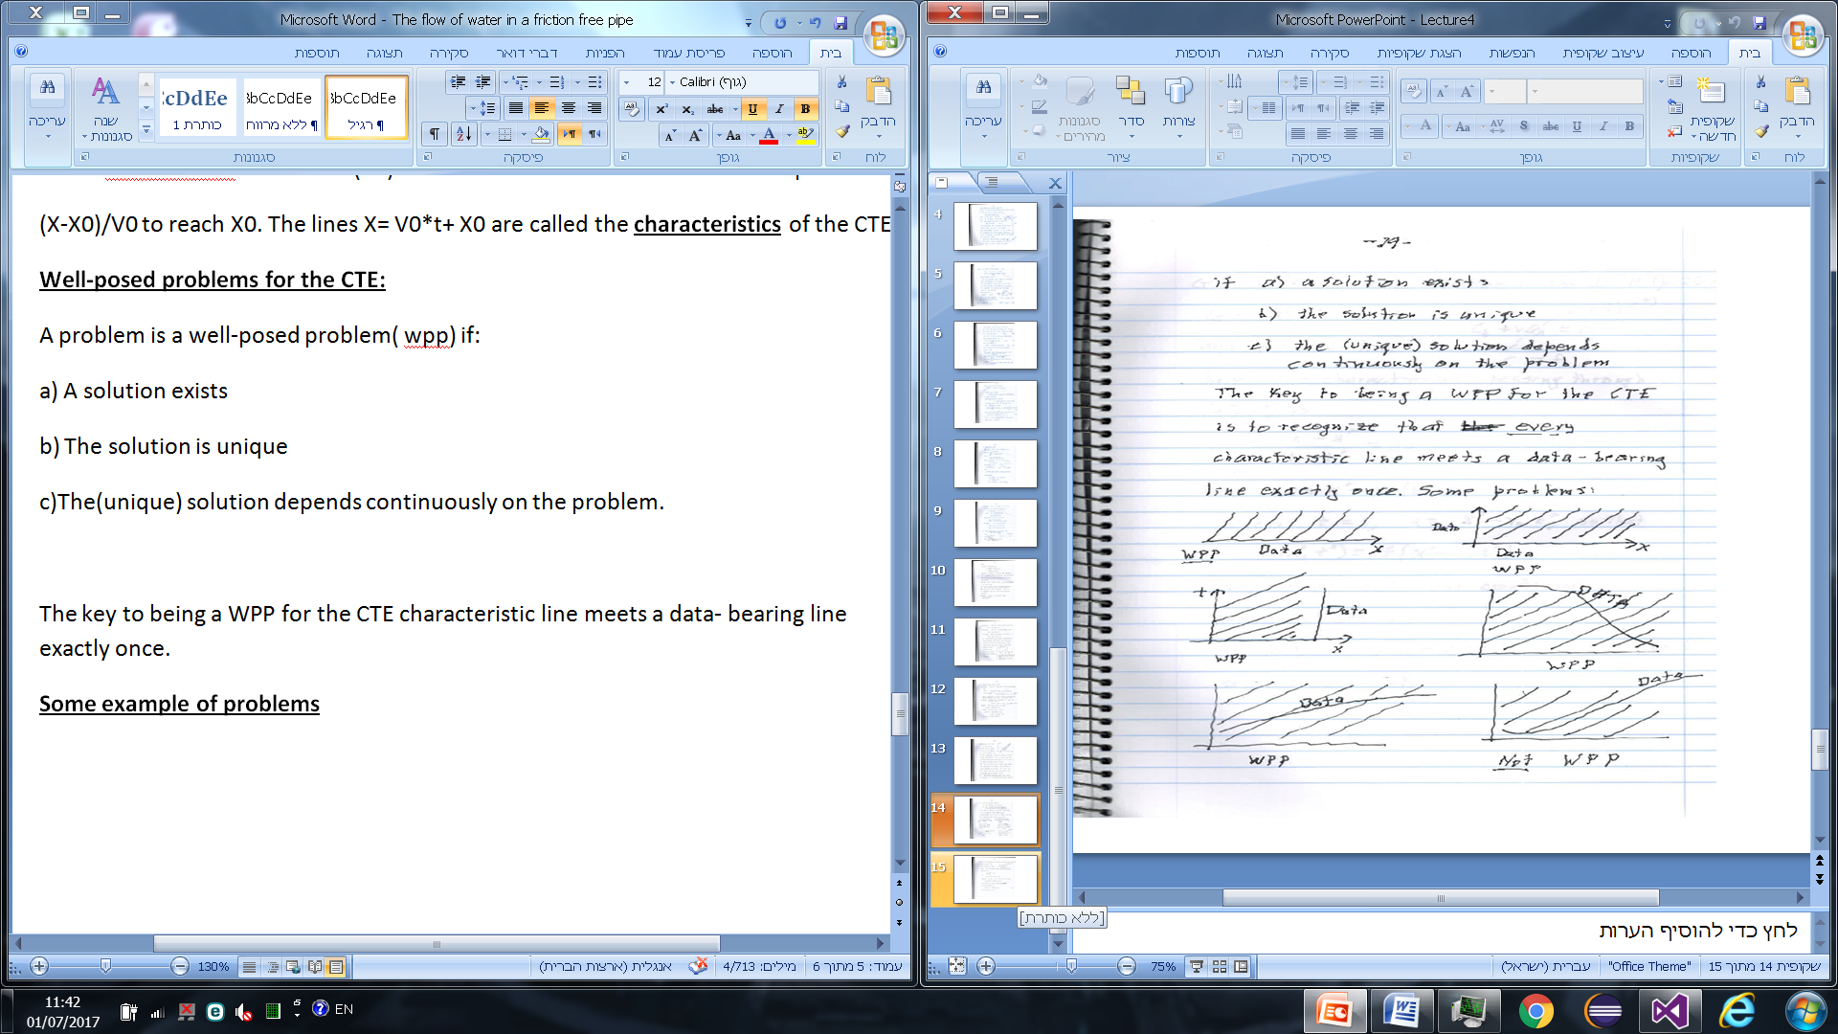

**The analytical solution of the IVP:**

Let (x*,t*) be

and position timp pair

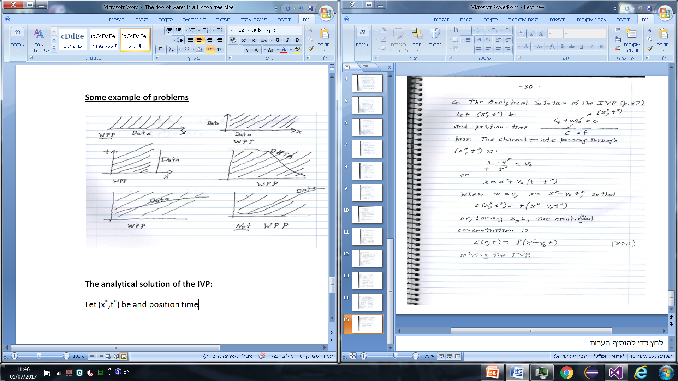

The characteristic passing through (x*,t*) is:

(x- x*) / (t- t*) = V0

or

x= x*+ V0(t- t*)

when t=0, x= x*-V0t*, so that C(x*,t*)= f(x*- V0t*)

or, for any x, t the contaminant concentration is:

C(x,t)= f(X-V0t) solving the IVP.